There is one more formulation of SVM called **nu-SVM**:

In nu-SVM we can control the **percentage of errors** that our model will made.

As nu >= fraction of errors.

If nu = 0.1, that means we allow 10% errors.

If nu = 0.01, that means we allow 1% errors.

That means nu-SVM gives the value that at most 5% of your training examples being misclassified.

Nu-SVM also provides the value that says that at least this much percentage of support vectors will be used. It’s not controlling no. of support vectors, it only saying that at least this much support vectors will be required or at least 5% of your training examples being support vectors

As nu <= fraction of support vectors.

If nu = 0.01, then there will at least 1% of n support vectors.

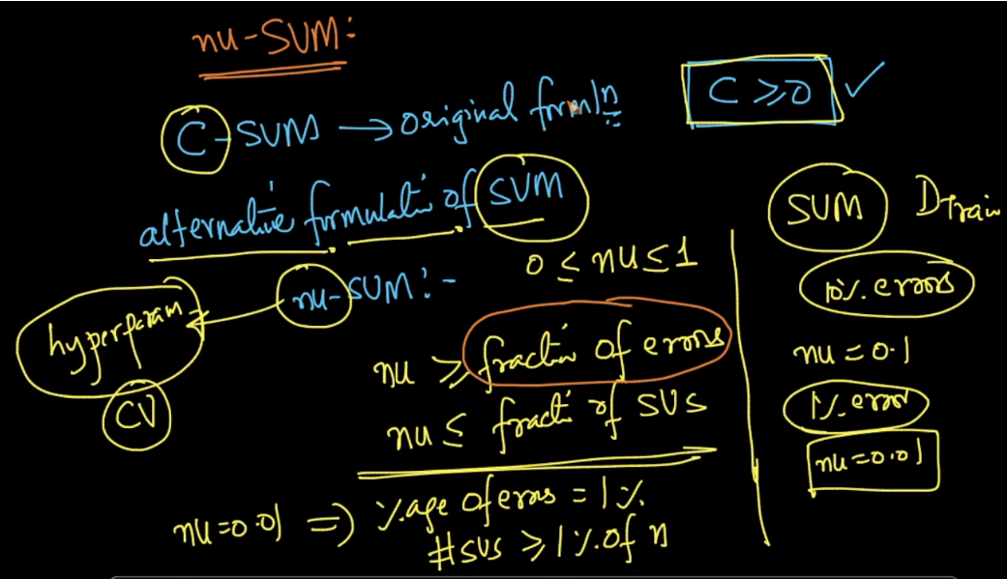

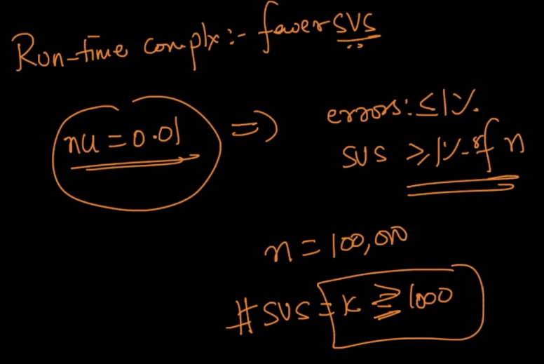

**Diff b/w c-SVM and nu-SVM**

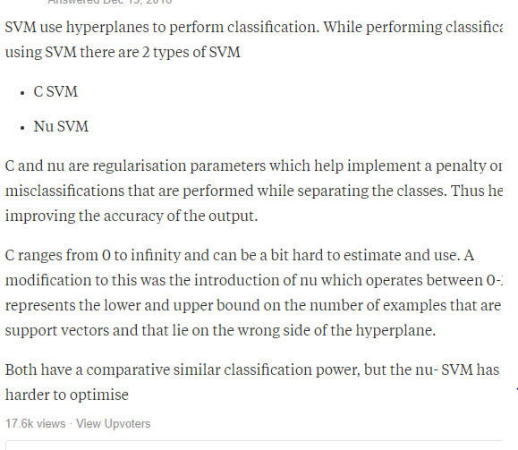

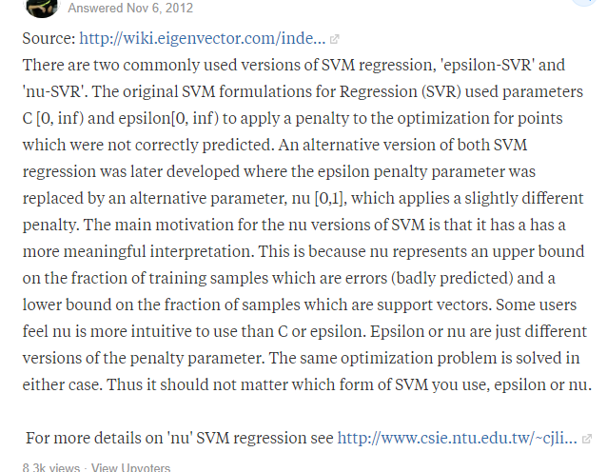

**Commetns:**

**1)**

